- Kode
html
<!DOCTYPE html>
<html lang="id">
<head>
<meta charset="UTF-8">
<title>Login</title>
</head>
<body>
<h1>Login</h1>

<form action="login.php" method="post">
<label>Username
<input type="text" name="username" required>
</label>
<br><br>
<label>Password
<input type="password" name="password" required>
</label>
<br><br>
<button type="submit">Masuk</button>
</form>
</body>
</html>

php
<?php

if ($_SERVER['REQUEST_METHOD'] !== 'POST') {
http_response_code(405);
echo 'Metode tidak diizinkan.';
exit;
}

$user = isset($_POST['username']) ? trim($_POST['username']) : '';
$pass = isset($_POST['password']) ? $_POST['password'] : '';

if ($user === '' || $pass === '') {
echo 'Username dan password wajib diisi.';
exit;
}

$USERNAME_BENAR = 'admin';
$PASSWORD_BENAR = 'rahasia123';

if ($user === $USERNAME_BENAR && $pass === $PASSWORD_BENAR) {
echo 'Login berhasil. Selamat datang, ' . htmlspecialchars($user, ENT_QUOTES, 'UTF-8') . '!';
} else {
echo 'Login gagal: username atau password salah.';
}

- Output
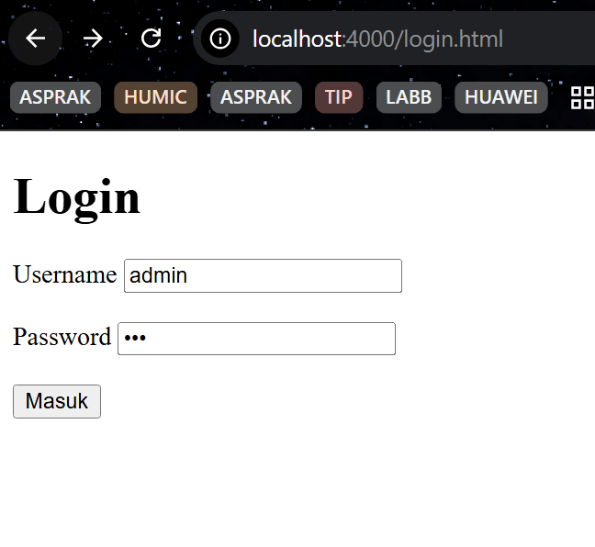
Jalankan php
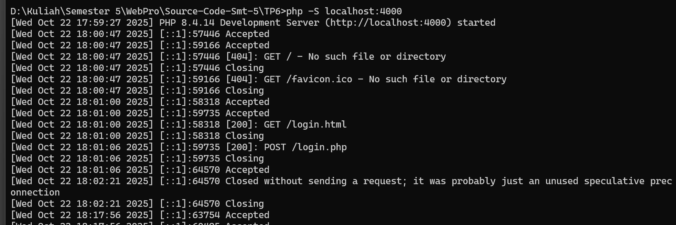
Misal berhasil login
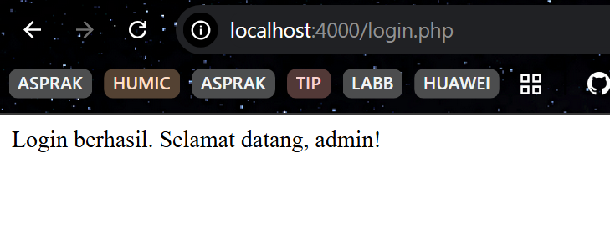
Misal gagal login
